Software Requirement Specification

TMSO-SRS-001

Version 1.0

**Revision History**

| Date | Version | Description | Author | Revised by |
| --- | --- | --- | --- | --- |
| 29/07/2013 | 1.0 | First version | Kha Nguyen | Khanh Nguyen |
| 09/08/2013 | 1.0 | Remove Close icon (“X” icon) on all pop-up, replace by Cancel button instead | Kha Nguyen | Khanh Nguyen |
| 13/08/2013 | 1.0 | Replace Advertise screen by Repair screen | Kha Nguyen | Khanh Nguyen |
|  |  |  |  |  |
|  |  |  |  |  |

Table of Contents

**1.** **Introduction** 5

**1.1** **Overview** 5

**1.2** **Scope** 5

**2.** **Functional Requirements** 6

**2.1** **Feature/Component #1: MyMobile Registration screen** 6

2.1.1 User Interfaces 6

2.1.2 Functional Requirements 6

**2.2** **Feature/Component #2: MyMobile Valuation Screen** 9

2.2.1 User Interfaces 9

2.2.2 Functional Requirements 9

**2.3** **Feature/Component #3: MyMobile Game Recommendation Screen** 11

2.3.1 User Interfaces 11

2.3.2 Functional Requirements 11

**2.4** **Feature/Component #4: MyMobile Podcast Recommendation Screen** 13

2.4.1 User Interfaces 13

2.4.2 Functional Requirements 13

**2.5** **Feature/Component #5: MyMobile Insurance Screen** 15

2.5.1 User Interfaces 15

2.5.2 Functional Requirements 15

**2.6** **Feature/Component #5: MyMobile Sell Screen** 17

2.6.1 User Interfaces 17

2.6.2 Functional Requirements 17

**2.7** **Feature/Component #6: MyMobile Donation Screen** 19

2.7.1 User Interfaces 19

2.7.2 Functional Requirements 19

**2.8** **Feature/Component #7: MyMobile Comparison Screen** 21

2.8.1 User Interfaces 21

2.8.2 Functional Requirements 21

**2.9** **Feature/Component #8: MyMobile Repair Screen.** 23

2.9.1 User Interfaces 23

2.9.2 Functional Requirements 23

**2.10** **Feature/Component #9: Mobile Inspection Screen** 26

2.10.1 User Interfaces 26

2.10.2 Functional Requirements 26

**2.11** **Feature/Component #9: MyMobile Trade Screen** 28

2.11.1 User Interfaces 28

2.11.2 Functional Requirements 28

**2.12** **Feature/Component #9: MyMobile Network Contract Screen** 30

2.12.1 User Interfaces 30

2.12.2 Functional Requirements 30

# **Introduction**

## **Overview**

This application allows identifies user’s phone and display’s it present value

## **Scope**

Demo version

Demo version is for display purpose only, not link to Database, not link to affiliated sites

Android OS: Android: OS 4.0.X to 4.1.X

* Android test devices: Galaxy Nexus, Nexus S, Samsung Galaxy S2

Android screen resolutions: 480x800, 720x1280

Support screen orientation in landscape mode only

# **Functional Requirements**

## **Feature/Component #1: MyMobile Registration screen**

### User Interfaces

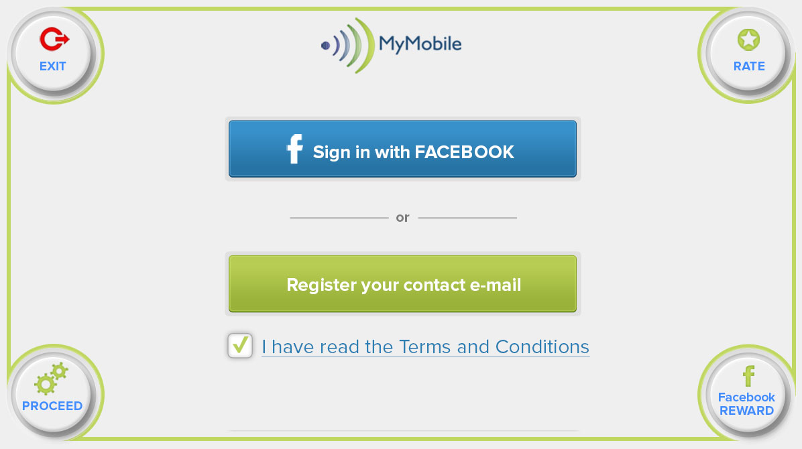

*Image1: Registration*

### Functional Requirements

|  |  |  |  |
| --- | --- | --- | --- |
| **Item** | **Description** | **Action** | **Response** |
| **MyMobile**  **Registration screen** | MyMobile Register Screen has 6 buttons:   * Sign in with Facebook * Register your contact e-mail * Proceed * Rate * Exit * Facebook REWARD   Screen has a "I have read the Terms and Conditions" link and a check box | N/A | N/A |
| **“I have read the Terms and Conditions”Link** | Use to display a pop up and have a check box | Tap on the Link | A pop up is showed with " Standard Terms and Conditions outlining Device Asset Management System role as an introducer with no lianbity here, plus prices and values are for guide purposes only." |
| A Check box as a condition to navigate to valuation screen | Tap on the check box | The check box is ticked |
| **Sign in with Facebook** | If the check box of "I have read the Terms and Conditions” link is ticked, a pop up come up with "In full version, this function links app to users Facebook account, allowing app to communicate directly with user via Facebook and user to post activity to Facebook." and a proceed button is embedded in pop up. | Tap on Sign in with Facebook button | A pop up is showed |
| Proceed button to navigate to valuation screen | Tap on the button | Navigate to Valuation screen |
| If the check box of "I have read the Terms and Conditions" link is not ticked, a pop up come up with “Please check Terms and Conditions first.” with OK button |  |  |
| **Register your contact e-mail** | If the check box of "I have read the Terms and Conditions" link is ticked, A pop up is opened for user to enter email With:   * E-mail field * Confirm E-mail field * Proceed button * Cancel Button | Tap on the button | A pop up is showed for user to enter |
| If user does not enter email or confirm email shows a pop up “ E-mail or confirm E-mail is empty, please fill out them!”  If E-mail or confirm E-mail is incorrect, A pop up is showed “E-mail or confirm E-mail is incorrect, please try again!” | N/A | N/A |
| Proceed button to navigate to valuation screen | Tap on the button | Navigate to Valuation screen |
| Cancel button to navigate to valuation screen | Tap on the button | Pop up is closed |
| If the check box of "I have read the Terms and Conditions" link is not ticked, a pop up come up with “Terms and Conditions Box with I agree.” | Tap on Sign in with Facebook button | A pop up is showed.  Note: then back to the main screen with the Terms & Conditions box now ticked |
| **Proceed** | Using to open a pop up comes up with "Before you use the great functions of this app, please either register a e-mail address or connect with Facebook so we can send you shopping voucher rewards in the future and stay in touch." and Cancel button | Tap on Proceed button | A pop up is showed |
| Cancel button to navigate to valuation screen | Tap on the button | Pop up is closed |
| **Rate** | Using to open a pop up comes up with "Before you use the great functions of this app, please either register a e-mail address or connect with Facebook so we can send you shopping voucher rewards in the future and stay in touch." and Cancel button | Tap on Rate button | A pop up is showed |
| Cancel button to navigate to valuation screen | Tap on the button | Pop up is closed |
| **Exit** | Closed application | Tap on Exit button | Application is closed |
| **Facebook REWARD** | Using to open a pop up comes up with "Before you use the great functions of this app, please either register a e-mail address or connect with Facebook so we can send you shopping voucher rewards in the future and stay in touch." | Tap on Facebook RE-WARD button | A pop up is showed |
| **Login policy** | Each time the App is started is goes to the Registration Screen | N/A | N/A |

### 

## **Feature/Component #2: MyMobile Valuation Screen**

### User Interfaces

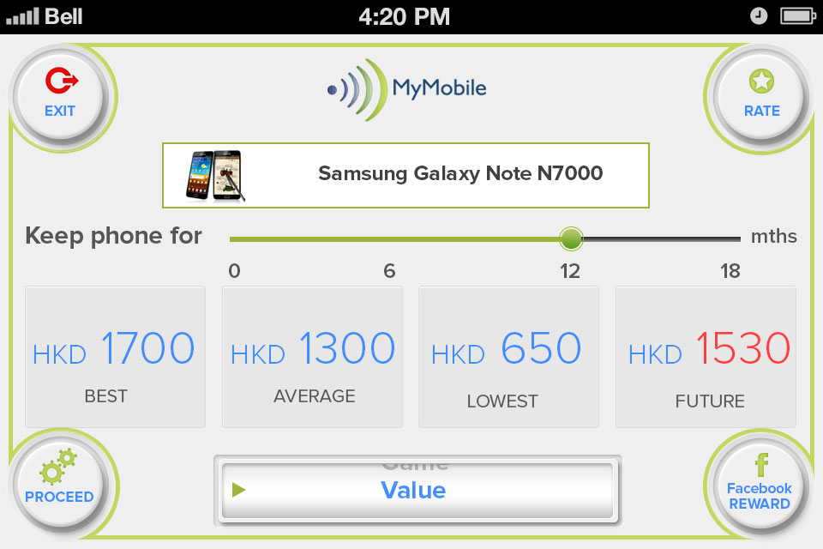

*Image2: Valuation*

### Functional Requirements

|  |  |  |  |
| --- | --- | --- | --- |
| **Item** | **Description** | **Action** | **Response** |
| MyMobile valuation Screen | MyMobile Valuation Screen has 4 buttons, 1 Scrolling (from 1 to 18months) and 1 navigation bar:   * Rate * Exit. * Proceed * Facebook Reward * Scrolling bar (from 1 to 18months). * 1 navigation bar | N/A | N/A |
| Rate | Shows Rate Pop Up - "In full version this will link to Google play store or iTunes enabling users to rate the app." and Cancel Button at the top right hand corner | Tap on Rate button | A Rate pop up is showed |
| Cancel button to close pop up | Tap on Cancel button | Pop up is closed |

|  |  |  |  |
| --- | --- | --- | --- |
| Navigation bar | Use to list items and pick the desired screen:   * Value. * Compare * MyContract * Trade * Sell * Repair * Games * Podcast * Insurance * Donate * Inspect * www.mymobile.com.hk | Tap on the button and pick the desired screen | List items are displayed and the desired screen is picked |
| Facebook Reward | Showing Facebook pop up "I just used MyMobiile App available from Google play, iTunes & www.mymobile.com.hk to find out how much my smartphone is worth today and in up to 18 months time and I received points towards a 10% discount electronics retail shopping voucher for telling my friends about it on Facebook." Post to Facebook & Receive Reward | Tap on the button | A pop up is displayed |
| Value of Phone | Displaying value derived of Samsung Galaxy Note N700 from PhoneDatabase in the screen first load and they are hyperlinked to Sell screen :   * Best Price = HKD 1530. * Average Price HKD 1350 * Lowest Price HKD 585 * Future Best Price HKD 1377 | N/A | N/A |
| Valuation of phone is pressed then sell screen is loaded | Tap on the value | Navigate to sell screen |
| Exit | Closed application | Tap on the button | Application is exit |
| Scrolling bar | Use to adjust valuation of Phone from 1 to 18 months with default starting position to be at 18 months. | Tap on scrolling bar to move the slider. | Value of phone is change from current value up to minus 10% |
| Proceed. | Navigate to desired screen from navigation bar | Tap on the button | Navigate to the desired screen |

### 

## **Feature/Component #3: MyMobile Game Recommendation Screen**

### User Interfaces

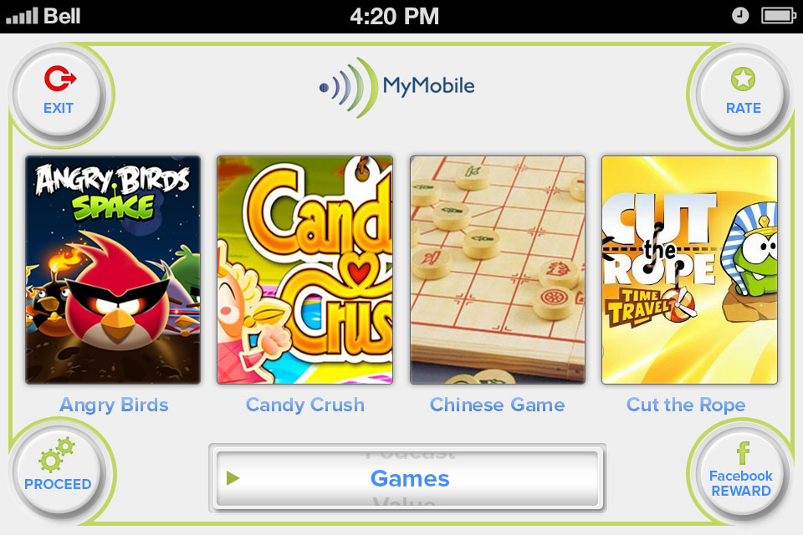

*Image3: Game*

### Functional Requirements

|  |  |  |  |
| --- | --- | --- | --- |
| **Item** | **Description** | **Action** | **Response** |
| **MyMobile Game Recommendation Screen** | MyMobile Game Recommendation Screen has 4 buttons and 1 navigation bar:   * Rate * Proceed * Facebook Reward * Navigation bar * Exit | N/A | N/A |
| **Game icons** | Screen displays 3 game icons linked to either Google play store or iTunes:   * Candy Crush * Order Up!! To Go * ZOOKEEPER BATTLE | Tap on Game icon | The link is opened with desired web browse |
| Rate | Shows Rate Pop Up - "In full version this will link to google play store or iTunes enabling users to rate the app." and Cancel Button at the top right hand corner | Tap on Rate button | A Rate pop up is showed |
| Cancel button to close pop up. | Tap on the button | Pop up is closed |
| Navigation bar | Use to list items and pick the desired screen:   * Value * Compare * MyContract * Trade * Sell * Repair * Games * Podcast * Insurance * Donate * Inspect * www.mymobile.com.hk | Tap on Navigation bar and pick the desired screen | List items are displayed and the desired screen is picked |
| Exit | Navigate to Valuation screen | Tap on Exit button | Navigate to Valuation screen |
| Proceed | Use with the navigation bar enables users to navigate to different screens | Tap on Proceed button | Navigate to the desired screen |
| Facebook Reward | Use to post to Facebook & Receive Rewards | Tap on Facebook Reward button | Show Facebook pop up "I just used MyMobiile App available from Google play, iTunes & www.mymobile.com.hk to find 3 brilliant mobile games and I received points towards a 10% discount electronics retail shopping voucher for telling my friends about it on Facebook." |

## 

## **Feature/Component #4: MyMobile Podcast Recommendation Screen**

### User Interfaces

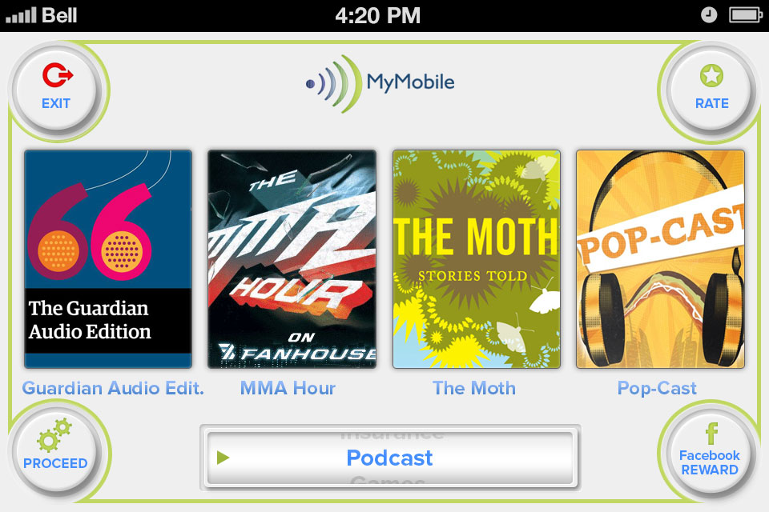

*Image4: Podcast*

### Functional Requirements

|  |  |  |  |
| --- | --- | --- | --- |
| **Item** | **Description** | **Action** | **Response** |
| **MyMobile Podcast Recommendation Screen** | MyMobile Podcast Recommendation Screen has 4 buttons and 1 navigation bar:   * Rate * Proceed * Navigation bar * Exit * Facebook Reward | N/A | N/A |
|  | Screen displays 3 postcasts and linked to these sites:   * The Moth * The Joe Rogan Experience * Freakanomics | Tap on the icon | The link is opened with new web browse |
| Rate | Shows Rate Pop Up - "In full version this will link to google play store or iTunes enabling users to rate the app." and Cancel Button at the top right hand corner | Tap on Rate button | A Rate pop up is showed |
| Cancel button to close pop up. | Tap on the button | Pop up is closed |
| Navigation bar | Use to list items and pick the desired screen:   * Value * Compare * MyContract * Trade * Sell * Repair * Games * Podcast * Insurance * Donate * Inspect * www.mymobile.com.hk | Tap on Navigation bar and pick the desired screen | List items are displayed and the desired screen is picked |
| Exit | Navigate to Valuation screen | Tap on Exit button | Navigate to Valuation screen |
| Proceed | To navigate to the selected screen in navigation bar | Tap on Proceed button | Navigate to the desired screen |
| Facebook Reward | Use to post to Facebook & Receive Rewards | Tap on Facebook Reward button | Pop up display I just used MyMobiile App available from Google play, iTunes & www.mymobile.com.hk to find 3 brilliant Podcasts and I received points towards a 10% discount electronics retail shopping voucher for telling my friends about it on Facebook.” |

### 

## **Feature/Component #5: MyMobile Insurance Screen**

### User Interfaces

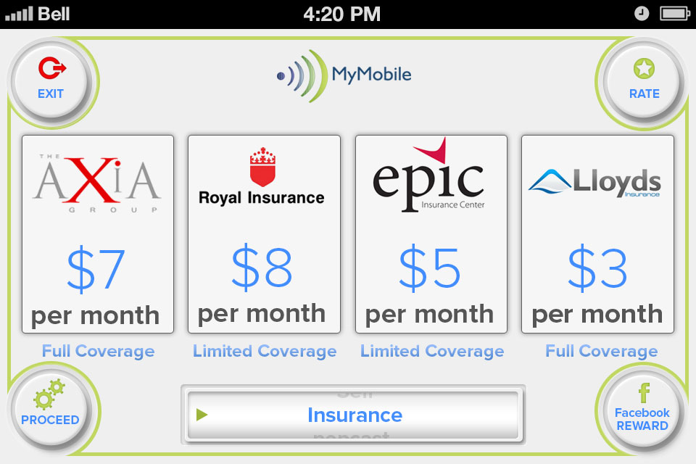

*Image5: Insurance*

### Functional Requirements

|  |  |  |  |
| --- | --- | --- | --- |
| **Item** | **Description** | **Action** | **Response** |
| **MyMobile Insurance Screen** | MyMobile Insurance Screen has 4 buttons and 1 navigation bar:   * Rate * Proceed * Facebook Reward * Exit * Navigation bar | N/A | N/A |
|  | Screen displays Four Quote's from Insurance companies with four icons | Tap on any icons | A pop up is appeared "This links to affiliated insurance partners website for fulfillment." |
| Rate | Shows Rate Pop Up - "In full version this will link to google play store or iTunes enabling users to rate the app." and Cancel Button at the top right hand corner | Tap on Rate button | A Rate pop up is showed |
| Cancel button to close pop up | Tap on the button | Pop up is closed |
| Proceed | Use with the navigation bar enables users to navigate to different screens | Tap on Proceed button | Navigate to the desired screen |
| Exit | Navigate to Valuation screen | Tap on Exit button | Navigate to Valuation screen |
| Navigation bar | Use to list items and pick the desired screen:   * Value * Compare * MyContract * Trade * Sell * Repair * Games * Podcast * Insurance * Donate * Inspect * www.mymobile.com.hk | Tap on Navigation bar and pick the desired screen | List items are displayed and the desired screen is picked |
| Facebook Reward | Use to post to Facebook & Receive Reward | Tap on Facebook Reward button | A Pop up " I just used MyMobiile App available from Google play, iTunes & www.mymobile.com.hk to insure my expensive smartphone for just 30 dollars per month and I received points towards a 10% discount electronics retail shopping voucher for telling my friends about it on Facebook." |

## **Feature/Component #5: MyMobile Sell Screen**

### User Interfaces

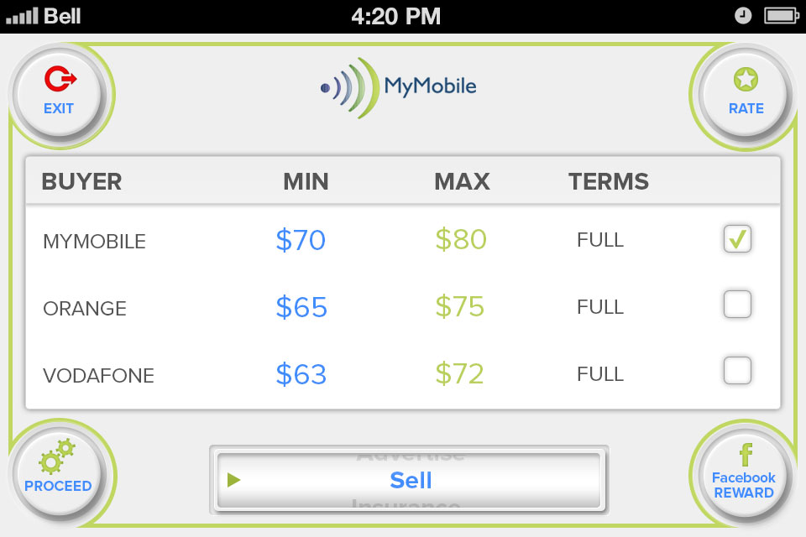

*Image6: Sell*

### Functional Requirements

|  |  |  |  |
| --- | --- | --- | --- |
| **Item** | **Description** | **Action** | **Response** |
| **MyMobile Sell Screen** | MyMobile Sell Screen has 4 buttons and 1 navigation bar:   * Rate * Proceed * Facebook Reward * Exit * Navigation bar | N/A | N/A |
|  | Screen displays the best buying prices for users mobile with Linked icons to affiliated partner websites. Each the buyer has a box and display the best buyer with name, Min and max of price, Term:   * Yodaphone $1500HKD $1800HKD Full * HKMobiles $ 1100HKD $1700HKD Full * Smart Recycle $800HKD $1200HKD PART | N/A | N/A |
| Rate | Shows Rate Pop Up - "In full version this will link to google play store or iTunes enabling users to rate the app." and Cancel Button at the top right hand corner | Tap on Rate button | A Rate pop up is showed |
| Cancel button to close pop up. | Tap on the button | Pop up is closed |
| Navigation bar | Use to list items and pick the desired screen:   * Value * Compare * MyContract * Trade * Sell * Repair * Games * Podcast * Insurance * Donate * Inspect * www.mymobile.com.hk | Tap on Navigation bar and pick the desired screen | List items is displayed and the desired screen is picked |
| Exit | Navigate to Valuation screen | Tap on Exit button | Navigate to Valuation screen |
| Facebook Reward | Use to post to Facebook & Receive Reward | Tap on Facebook Reward button | Pop up display " I just used MyMobiile App available from Google play, iTunes & www.mymobile.com.hk to Sell my old smartphone and I received points towards a 10% discount electronics retail shopping voucher for telling my friends about it on Facebook." |
| Check box | Each The best buyer has a check box to link the affiliated web of buyer | Tap on the check box | Check box is ticked |
| Proceed | When user has box ticked and presses proceed, Pop Up box appears with "User will be sent to affiliates website for fulfilment.” | Tap on Proceed button | Pop up is showed |

## **Feature/Component #6: MyMobile Donation Screen**

### User Interfaces

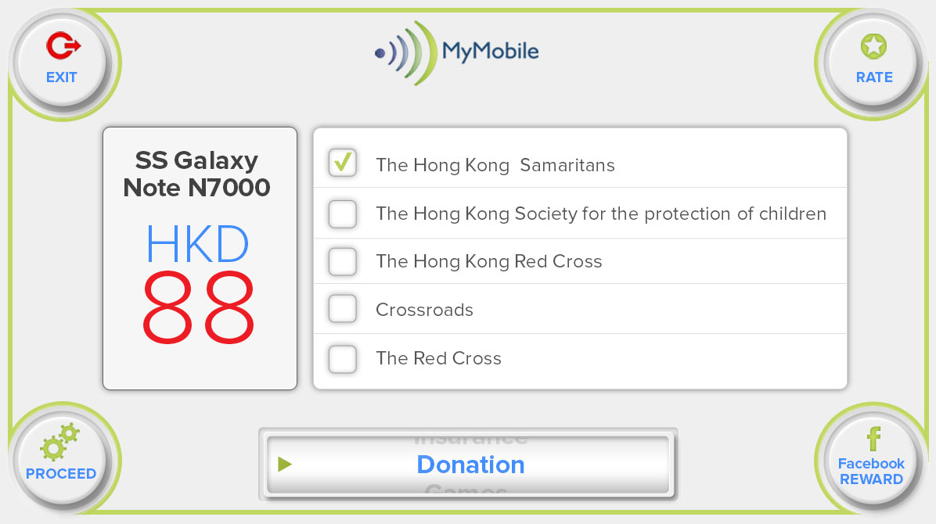

*Image7: Donation*

### Functional Requirements

|  |  |  |  |
| --- | --- | --- | --- |
| **Item** | **Description** | **Action** | **Response** |
| **MyMobile Donation Screen** | MyMobile Donation Screen has 4 buttons and a field to input Money with default currency is $.   * Rate * Proceed * Facebook Reward * Exit * Navigation bar | N/A | N/A |
| Screen displays info of phone   * The Phone is the Samsung Galaxy Note N700 * The Price is $1700HKD | N/A | N/A |
| Charity options will be:   * The Hong Kong Samaritans * The Hong Kong Society for the protection of children * The Hong Kong Red Cross * Crossroads * The Red Cross   Note: only a charity is ticked | Tap on the box | The desired charity is ticked |
| Rate | Shows Rate Pop Up - "In full version this will link to google play store or iTunes enabling users to rate the app." and Cancel Button at the top right hand corner | Tap on Rate button | A Rate pop up is showed |
| Cancel button to close pop up | Tap on the button | Pop up is closed |
| Navigation bar | Use to list items and pick the desired screen:   * Value * Compare * MyContract * Trade * Sell * Repair * Games * Podcast * Insurance * Donate * Inspect * www.mymobile.com.hk | Tap on the navigation bar and pick the desired screen | List items are displayed and the desired is picked |
| Exit | Navigate to Valuation screen | Tap on Exit button | Navigate to Valuation screen |
| Facebook Reward | Use to post to Facebook & Receive Reward | Tap on Facebook Reward button. | Pop up displays " I just used MyMobiile App available from Google play, iTunes & www.mymobile.com.hk to sell my smartphone and donate the proceeds to The hong Kong Society for the protection of children and I received points towards a 10% discount electronics retail shopping voucher for telling my friends about it on Facebook." |
| **Proceed** | Use to display A pop up appears "We will send a prepaid envelop to you from Recycle Limited wwww.recycle limited.com, once inspected all proceeds of the sale of your phone will go to your chosen charity and you will receive a receipt within 30 days. Please let people know of you kind gesture on Facebook. Thank You !" when user selects charity | Tap on Proceed button | A pop up is showed |

### 

## **Feature/Component #7: MyMobile Comparison Screen**

### User Interfaces

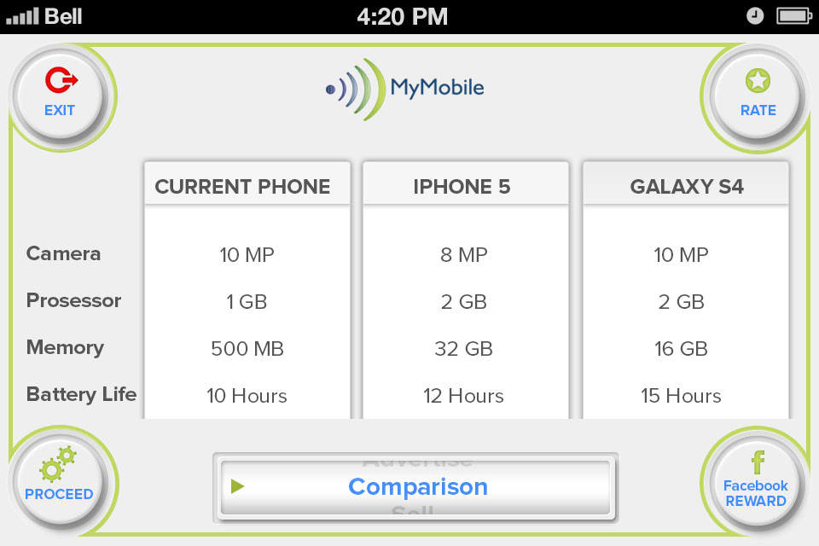

*Image8: Comparison*

### Functional Requirements

|  |  |  |  |
| --- | --- | --- | --- |
| **Item** | **Description** | **Action** | **Response** |
| **MyMobile Comparison Screen** | MyMobile Comparison Screen has 3 buttons and a field to input Money with default currency is $.   * Rate. * Exit. * Facebook Reward. * Proceed. * Navigation bar. | N/A | N/A |
|  | Screen Displays the info of the best 2 smartphones specs compared to the users current phone with the info:  Camera & Video  Screen size & Resolution  Processor & Data Speed  Weight  Ram & Memory | N/A | N/A |
| Rate | Shows Rate Pop Up - "In full version this will link to google play store or iTunes enabling users to rate the app." and Cancel Button at the top right hand corner | Tap on Rate button | A Rate pop up is showed |
| Cancel button to close pop up. | Tap on the button | Pop up is closed |
| Navigation bar | Use to list items and pick the desired screen:   * Value * Compare * MyContract * Trade * Sell * Repair * Games * Podcast * Insurance * Donate * Inspect * www.mymobile.com.hk | Tap on the navigation bar and pick the desired screen | List items are displayed and the desired is picked |
| Exit | Navigate to Valuation screen | Tap on Exit button | Navigate to Valuation screen |
| Facebook Reward | Use to Post to Facebook & Receive Reward. | Tap on Facebook Reward button. | Pop up displays button "I just used MyMobiile App available from Google play, iTunes & www.mymobile.com.hk to compare my smartphones specs to the latest models and I received points towards a 10% discount electronics retail shopping voucher for telling my friends about it on Facebook." |
| **Proceed** | Navigate to desired screen from navigation bar | Tap on Proceed button | Navigate to the desired screen |

## **Feature/Component #8: MyMobile Repair Screen.**

### User Interfaces

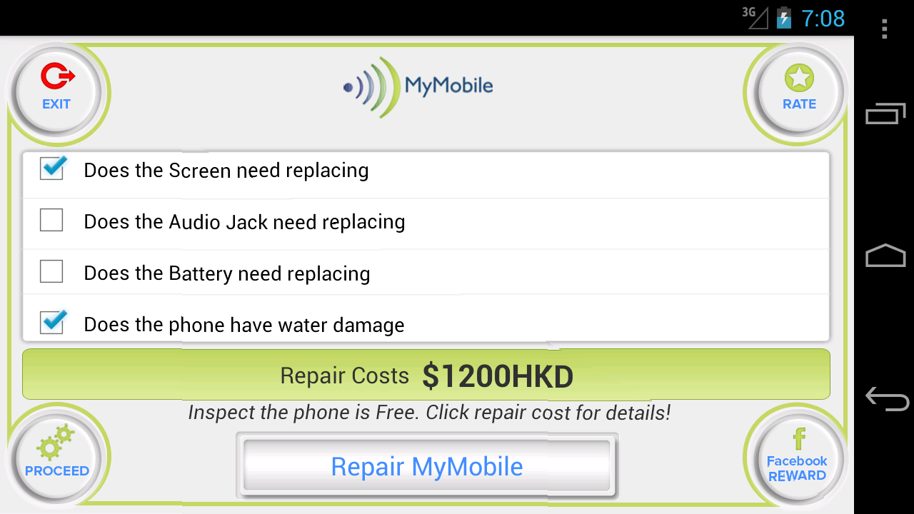

*Image9: Repair*

### Functional Requirements

|  |  |  |  |
| --- | --- | --- | --- |
| **Item** | **Description** | **Action** | **Response** |
| **MyMobile Repair Screen** | MyMobile Repair Screen displays a standard Repair for the users smartphone and has 4 buttons:   * Rate * Proceed * Facebook Reward * Navigation bar * Exit | N/A | N/A |
|  | Displays a selection of questions about What user wants to repair:   * Does the Screen need replacing * Does the Audio Jack need replacing * Does the Battery need replacing * Does the phone have water damage   Displays a text below Repair Costs: “Inspect the phone is Free Click repair cost for details” | N/A | N/A |
| **Display Value** | The string to display value.Based on What the user answers:   * Does the Screen need replacing - If checked Add $300 to the repair costs * Does the Audio Jack need replacing - if checked Add $250 to the repair costs * Does the Battery need replacing - if checked add $750 to the repair costs * Does the phone have water damage - If checked add $900 to the repair costs * if the user just checks Screen needs replacing the cost shows $300 * if the user checks Screen needs replacing and water damage the repair cost shows $1200 | N/A | N/A |
| **Box Next** | Each the question has a Check Box to pick | Tap on to boxt next answer questions | Box next is selected. Then expected value is displayed |
| **Repair Costs** | A Pop up shows, a dummy address as follows :  “We have e-mailed you a discount Reference code please show it to the repair centre & Please take your iPhone to  MyMobile Repairs  18 Harcourt Street  Wan Chai  Hong Kong  Ph. 2111 1111.” | Tap on Repair Cost Link | A pop up is showed |
| Rate | Shows Rate Pop Up - "In full version this will link to google play store or iTunes enabling users to rate the app." and Cancel Button at the top right hand corner | Tap on Rate button | A Rate pop up is showed |
| Cancel button to close pop up | Tap on the button | Pop up is closed |
| Navigation bar | Use to list items and pick the desired screen:   * Value * Compare * MyContract * Trade * Sell * Repair * Games * Podcast * Insurance * Donate * Inspect * www.mymobile.com.hk | Tap on the navigation bar and pick the desired screen | List items are displayed and the desired is picked |
| Facebook Reward | Use to post to Facebook & Receive Reward | Tap on Facebook Reward button | Pop up display " I just used MyMobiile App available from Google play, iTunes & [www.mymobile.com.hk](http://www.mymobile.com.hk/) to get a quote to repair it and I received points towards a 10% discount electronics retail shopping voucher for telling my friends about it on Facebook." |
| Exit | Navigate to Valuation screen | Tap on Exit button | Navigate to Valuation screen |
| Proceed | Use with the navigation bar enables users to navigate to different screens | Tap on Proceed button | Navigate to the desired screen |

## **Feature/Component #9: Mobile Inspection Screen**

### User Interfaces

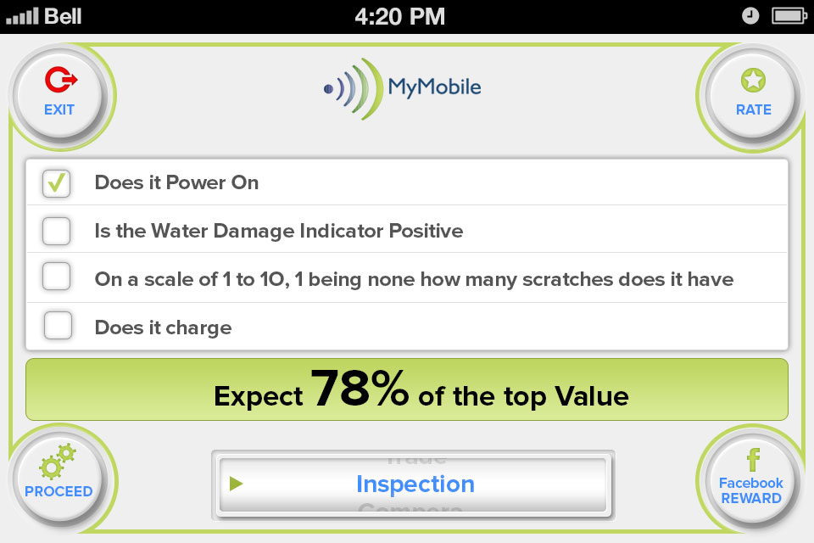

*Image10: Inspection*

### Functional Requirements

|  |  |  |  |
| --- | --- | --- | --- |
| **Item** | **Description** | **Action** | **Response** |
| **MyMobile Inspection Screen** | Inspection Screen displays has 4 buttons and 1 navigation bar:   * Rate * Navigation bar * Facebook Reward * Exit * Proceed | N/A | N/A |
|  | Displays a selection of questions about the state of the users phone.   * Does the phone power on * Is the Water Damage Indicator not Positive * Is the Screen not cracked * Does it charge | N/A | N/A |
| **Display value** | The string to display value.Based on weather the user answers:   * Does it power on Yes - if unchecked reduce 10% * Is the water damage indictor not positive - if unchecked reduce 40% * Is the screen cracked -if unchecked reduce 20% * Does it charge -if unchecked reduce 10% * if all 4 boxes are unchecked the customer can still expect to get 20% of the top value of the phone and If none of the boxes are unchecked get 100% | N/A | N/A |
| Rate | Shows Rate Pop Up - "In full version this will link to google play store or iTunes enabling users to rate the app." and Cancel Button at the top right hand corner | Tap on Rate button | A Rate pop up is showed |
| Cancel button to close pop up | Tap on the button | Pop up is closed |
| Navigation bar | Use to list items and pick the desired screen:   * Value * Compare * MyContract * Trade * Sell * Repair * Games * Podcast * Insurance * Donate * Inspect * www.mymobile.com.hk | Tap on the navigation bar and pick the desired screen | List items are displayed and the desired screen is picked |
| Exit | Navigate to Valuation screen | Tap on Exit button | Navigate to Valuation screen |
| Proceed | Use with the navigation bar enables users to navigate to different screens | Tap on Proceed button | Navigate to the desired screen |
| Facebook Reward | Use to post to Facebook & Receive Reward with a pop up is showed “I just used MyMobiile App available from Google play, iTunes & www.mymobile.com.hk to help me assess my smartphones condition / value and I received points towards a 10% discount electronics retail shopping voucher for telling my friends about it on Facebook." | Tap on Facebook Reward button | A pop up is showed |
| **Box Next** | Each the question has a Check Box to pick | Tap on to box next answer questions | Box next is selected. Then expected % value is displayed |

## **Feature/Component #9: MyMobile Trade Screen**

### User Interfaces

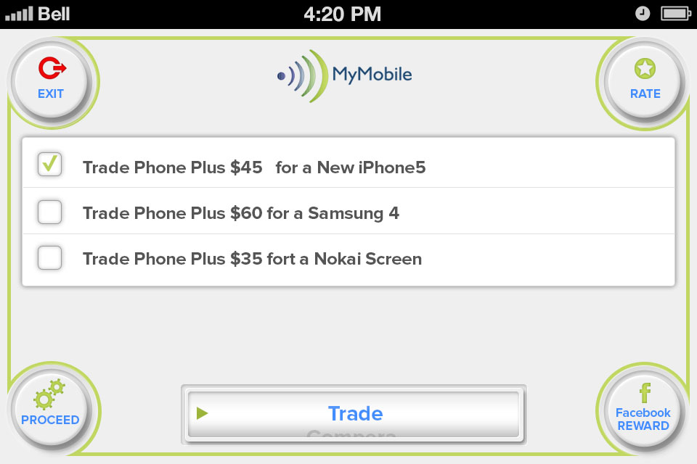

*Image11: Trade*

### Functional Requirements

|  |  |  |  |
| --- | --- | --- | --- |
| **Item** | **Description** | **Action** | **Response** |
| **MyMobile Trade Screen** | Trade Screen displays has 4 buttons and 1 navigation bar:   * Rate * Proceed * Facebook Reward * Navigation bar * Exit | N/A | N/A |
|  | Displays a selection of the best trade in  deals with our affiliated partners for that phone:   * Trade Phone Plus $2000HKD for a iPhone5S * Trade Phone Plus $1500HKD for a Samsung Galaxy Note II * Trade Phone Plus $1000HKD for a Google Nexus 4 * Trade Phone Plus $1000HKD for a Nokia Limia 920 * Trade Phone Plus $900 for a Motorola Droid RAZR | N/A | N/A |
| Rate | Shows Rate Pop Up - "In full version this will link to google play store or iTunes enabling users to rate the app." and Cancel Button at the top right hand corner | Tap on Rate button | A Rate pop up is showed |
| Cancel button to close pop up | Tap on the button | Pop up is closed |
| Exit | Navigate to Valuation screen | Tap on Exit button | Navigate to Valuation screen |
| Navigation bar | Use to list items and pick the desired screen:   * Value * Compare * MyContract * Trade * Sell * Repair * Games * Podcast * Insurance * Donate * Inspect * www.mymobile.com.hk | Tap on the navigation bar and pick the desired screen | Display list items and the desired screen is picked |
| Facebook Reward | Use to post to Facebook & Receive Reward | Tap on Facebook Reward button | Pop up display "I just used MyMobiile App available from Google play, iTunes & www.mymobile.com.hk to trade in my old smartphone for a new model and I received points towards a 10% discount electronics retail shopping voucher for telling my friends about it on Facebook." |
| **List of affiliated partner** | Each the partner has a check box and name  Note: Navigation * once the user moves the navigation bar any boxes which are checked, become unchecked | Tap on check box | The affiliated partner is ticked |
| **Proceed** | Pick proceed to Links to affiliated partner website which is ticked | Tap on Proceed button | A info pop up appears " this action will link directly to our affiliated partners website for fulfilment of order." |
| Ok button uses to link the affiliated partners website is : http://www.fortress.com.hk/en/home/ | Tap on Ok button | The affiliated partners website is linked |
| Cancel button on top right hand corner to close pop up | Tap on the button | Pop up is closed |

## **Feature/Component #9: MyMobile Network Contract Screen**

### User Interfaces

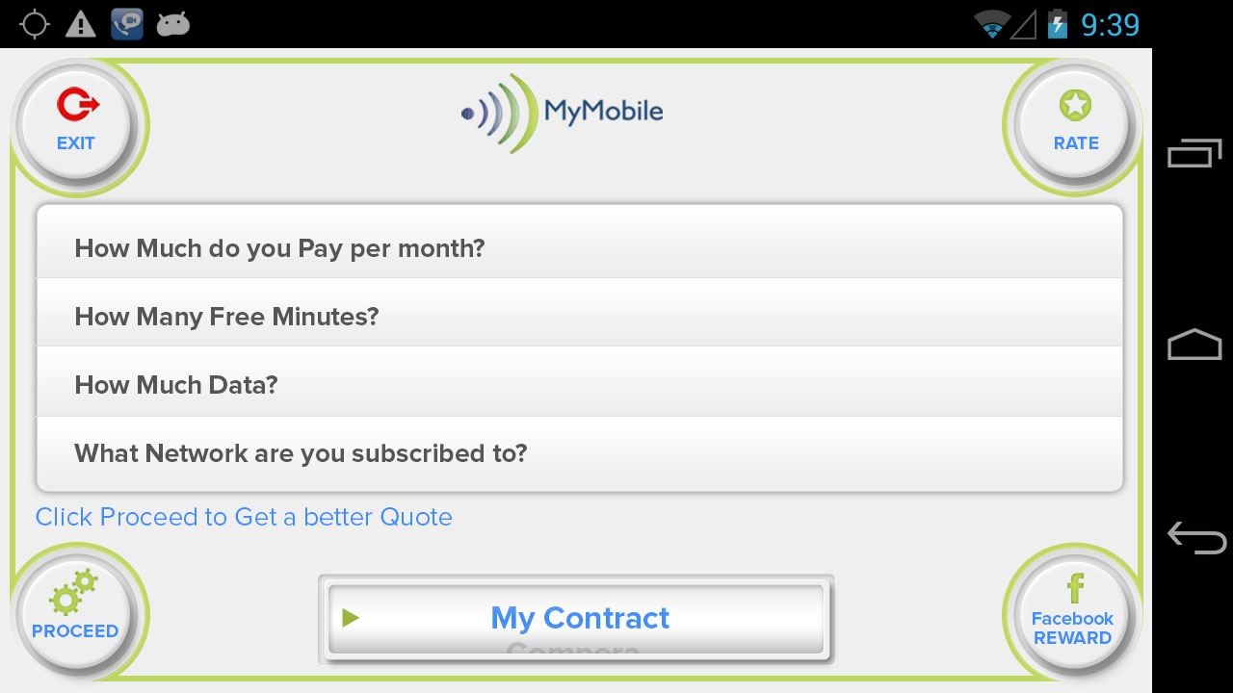

*Image12: MyContract*

### Functional Requirements

|  |  |  |  |
| --- | --- | --- | --- |
| **Item** | **Description** | **Action** | **Response** |
| **MyMobile Trade Screen** | Trade Screen displays has 4 buttons and 1 navigation bar:   * Rate * Proceed * Facebook Reward * Exit * Navigation bar | N/A | N/A |
|  | Displays a series of question buttons:   * What Network are you subscribed to? * How much Data? * How many free minutes? * How much you pay? | N/A | N/A |
| Rate | Shows Rate Pop Up - "In full version this will link to google play store or iTunes enabling users to rate the app." and Cancel Button at the top right hand corner | Tap on Rate button | A Rate pop up is showed |
| Cancel button to close pop up | Tap on the button | Pop up is closed |
| Navigation bar | Use to list items and pick the desired screen:   * Value * Compare * MyContract * Trade * Sell * Repair * Games * Podcast * Insurance * Donate * Inspect * www.mymobile.com.hk | Tap on the navigation bar and pick the desired screen | Display list items and the desired screen is picked |
| Exit | Navigate to Valuation screen | Tap on Exit button | Navigate to Valuation screen |
| Facebook Reward | Use to post to Facebook & Receive Reward. | Tap on Facebook Reward button | Pop up display "I just used MyMobiile App available from Google play, iTunes & [www.mymobile.com.hk](http://www.mymobile.com.hk/) to get a better cheaper mobile contract quote and I received points towards a 10% discount electronics retail shopping voucher for telling my friends about it on Facebook.” |
| **Question list** | What Network are you subscribed to?  Has 5 options to answer, each options have a check box before it   * China Mobile * 3 * CSL * PCCW * Smartone | Tap on the check box | Desired Network provider is ticked |
| How much Data?  Has 9 options to answer, each options have a check box before it   * Zero * Unlimited * 200 * 400 * 600 * 800 * 1gb * 1.5gb * 2 and above | Tap on the check box | Desired Data is ticked |
| How many free minutes?  Has a text field to enter. | Tap on the text field. | The info is entered. |
| How much you pay?  Has a text field to enter. | Tap on the text field. | The info is entered. |
| **Proceed** | Display a pop up with "We will make sure you are on the best deal, if not we will send you out better deals on offer from your current and competitor networks." | Tap on Proceed button. | Pop up is showed. |

***---------- End of Document ----------***